D3.2 Evaluation Solution Demonstrator
WP 3 Evaluation Tools

Dissemination Level: Public

Deliverable Type: DEM (Demonstrator, pilot, prototype)

Date: 15th March 2023

Author: Bartosz Fabisiak

DOCUMENT INFORMATION PAGE
Grant Agreement No. 101047665 | Deliverable Due Date: 28 Feb 2023
Project Starting Date: 01 January 2022 (18 months) | Actual Submission: 15 Mar 2023
Deliverable Number: 3.2 (WP3) | Leading Partner: ITTI

KEY WORDS
INEGMA, UCPM, exercise, evaluation, software, tools, demonstrator

AUTHORS & CONTRIBUTORS
Author | Institution | Entire Document-Section-Appendix
Bartosz Fabisiak | ITTI | Entire Document

REVIEWERS
Kamila Stroińska | ITTI | Entire Document-Section-Appendix
Robert Orczyk | ITTI | Entire Document-Section-Appendix

Disclaimer

The text, figures and tables in this report can be reused under a provision of the Creative Commons Attribution 4.0 International License. Logos and other trademarks are not covered by this licence.
The content of the publication herein is the sole responsibility of the publishers and it does not necessarily represent the views expressed by the European Commission or its services.
While the information contained in the documents is believed to be accurate, the authors(s) or any other participant in the INEGMA-E² consortium make no warranty of any kind with regard to this material including, but not limited to the implied warranties of merchantability and fitness for a particular purpose.
Neither the INEGMA-E² Consortium nor any of its members, their officers, employees or agents shall be responsible or liable in negligence or otherwise however in respect of any inaccuracy or omission herein.
Without derogating from the generality of the foregoing neither the INEGMA-E² Consortium nor any of its members, their officers, employees or agents shall be liable for any direct or indirect or consequential loss or damage caused by or arising from any information advice or inaccuracy or omission herein.

Responsibility of this publication lies entirely with the authors. The European Commission is not responsible for any use that may be made of the information contained therein.

Table of Contents

About the project 6
About this deliverable 6
Abbreviations and Glossary 7
Evaluation Solution Demonstrator concept 7
Evaluation Tool Demonstrator in exercise evaluation support 8
Sustainability of the Demonstrator 9
Annexes 10

List of Figures
Figure 1 Demonstrator Architecture 8
Figure 2 Toolkit Architecture 9

About the project
In the context of civil protection exercises, well-considered and extensive evaluation plays a crucial role in documenting best practices and shortcomings happening during those exercises. By noting lessons learnt, evaluation is essential for constant improvement in training efforts, thus advancing the capacity of response units in the European Union and its neighbouring countries to deal with real disaster scenarios. INEGMA-E² is building upon an upcoming approach of independent evaluation and aims for a new level of exercise evaluation, which will meet high standards concerning documentation, replicability, and goal orientation.
The three pillars of the project are:
- The development of an adequate and versatile evaluation methodology, addressing the different types of existing exercises. Each of those has different needs and goals, thus requiring diverse evaluation approaches.
- Exploration of the great number of existing tools, which can facilitate data collection throughout the exercise process. Software solutions and technical tools like databases and handhelds empower the evaluators to collect a great amount of data even under difficult circumstances, often part of the training reality.
- Establishment of an international pool of evaluators, which will be accessible by all institutions managing those kinds of exercises, to ensure the availability of highly skilled experts when needed. The project will develop a set of skill requirements, which those invited to the pool of evaluators will have to meet.
A strong interconnection of all three essential fields - methods, tools and network – is crucial for setting new standards in exercise evaluation. By ensuring the provision of results for future exercises INEGMA-E² will significantly contribute to a continuous improvement of exercise outcomes. In addition, it will connect experts in exercise evaluation, will create a mechanism of sharing knowledge and good practices and will be designed for further growth and scale up.

About this deliverable
This document is a short explanatory document to the main product of the D3.2 Evaluation Solution Demonstrator of Task 3.3 “Setting up a demonstrator”. It describes the concept of the Demonstrator and broadly explains its usage in the exercise evaluation process. The creation of the Deliverable 3.2 was preceded by the activities in Task 3.1 “User requirements collection” and Task 3.2 “Matching of available solutions with end user requirements”. Based on the collected data, requirements and information on the existing solutions, the Demonstrator of evaluation software toolkit was developed and delivered in a form of zip file: Demonstator.zip – an archive containing demonstrator’s installation and configuration files for the local instance installation (in the attachment). The created solution was tested and evaluated in an exercise ”Host Nation Support Table Top Exercise Moldova” between 22-24 February 2023. Short report on that test and all other relevant data are provided in the attached archive MoldovaExercise.zip. It also contains inputs and results from the Demonstrator testing during that event.
This document itself details the Demonstrator concept, and the Demonstrator architecture used in the exercise evaluation support. It focuses also on the sustainability of the Demonstrator as a project result.

Abbreviations and Glossary
A common glossary of terms for all INEGMA-E2 deliverables, as well as a list of abbreviations, will be made available at the INEGMA-E² website.

Evaluation Solution Demonstrator concept
The Demonstrator is a preconfigured set of tools supporting the process of exercise evaluation. The Demonstrator consists of the following tools:
- Observation Support Tool (OST) – application for implementing and filling out questionnaires during an ongoing exercise,
- Apache Kafka – application which provides a unified data transfer interface for multiple data sources,
- Elasticsearch – search and analytics engine which can store and index different types of data,
- Kibana – visualisation and management tool for Elasticsearch.

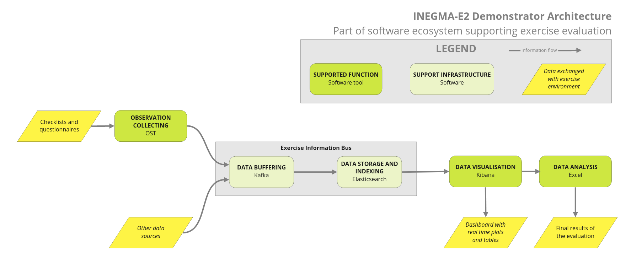
Figure 1 Demonstrator Architecture
Figure 1 shows flow of data through the Demonstrator. First in the flow is OST. Checklists and questionnaires made by the evaluators for a specific exercise are imported into OST. That enables evaluators to fill out those checklists and questionnaires in the OST application. Every answer given in the checklist or questionnaire then is transferred to Kafka. Kafka also makes it possible to integrate other sources of data into the demonstrator. Those other sources may be, for example, an application which measures the temperature of a fuel tank and stores it for fuel tank monitoring purposes. When Kafka receives data from OST or other sources, that data is uploaded to Elasticsearch. Elasticsearch stores that data and makes it accessible for Kibana where it can be easily viewed, filtered and parsed by evaluators through Kibana’s graphical interface. It’s possible to create a dashboard showing all data being gathered about the exercise in almost real-time which passes through the Demonstrator. Such a dashboard makes it possible to add many different visualisations of gathered data in the form of diagrams, graphs, charts and many others.

Evaluation Tool Demonstrator in exercise evaluation support
Demonstrator covers most of the Exercise Evaluation Process (XEP) described in detail in deliverable D3.3. The Demonstrator can collect data during an exercise and then enables evaluators to work with that gathered data. It does not support the preparation of the evaluation concept. It’s also not practical to use it to survey a large group of people. Other tools from the Evaluation Support Tool set (EST) must be used for these purposes.

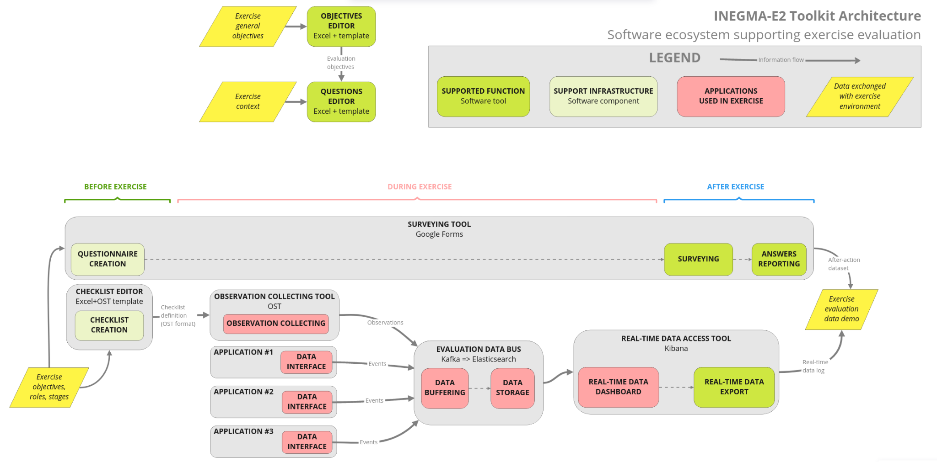
Figure 2 Toolkit Architecture
Figure 2 presents a proposition of the evaluation plan creation and its execution. For the preparation of the exercise objectives and KPIs it is recommended to use an Excel template. An example of such a template was attached to this document (Exercise evaluation form - attached to this document). For preparation of the questionnaires to be completed in the ongoing exercise, it is mandatory to use the “OST questionnaire template” (also attached). This file, when filled with questions, can be imported into the OST application. To carry out surveying after an exercise has occurred it is recommended to use the Google Forms. It does not require the users to be registered. It simplifies reaching a wider range of recipients. Its results can be exported to a csv file and imported into Kibana if needed.

Sustainability of the Demonstrator
One of the important aspects of the INEGMA E² is to ensure that results are accessible and usable also after the completion of the project. Therefore, even after the end of INEGMA E², every person interested in using the Demonstrator will be able to download the files from GitHub under https://github.com/itti-pl/demonstrator and create their own instance of the Demonstrator on their computer. Demonstrator is shared on MIT licence. It grants users the unrestricted right to use, copy, modify and distribute (including sell) the original or modified program in binary or source form. The only requirement is that the licensing terms and author information must be retained in all versions.

Annexes
- Demonstrator.zip - archive containing demonstrators installation and configuration files for the local instance installation.
- Moldova Exercise.zip - archive containing information on “Host Nation Support Table Top Exercise Moldova” hosted in Moldova between 22-24 February 2023. It also contains inputs and results from the Demonstrator testing during that event. It includes:
  - Demonstrator Testing Report.docx - report on usage of the Demonstrator tool set in the exercise in Moldova.
  - EU HNS TTX Moldova Exercise Handbook.pdf - Exercise Handbook describing exercise in Moldova.
  - Evaluation questionnaire EU HNS TTX.docx - Questionnaire used by evaluators in Moldova in the evaluation process.
  - OST Questions.xlsx - file containing questions from “Evaluation questionnaire EU HNS TTX.docx” written in template which can be imported into the OST application.
  - Dashboard in Kibana.png - file presenting example of a dashboard in Kibana with data gathered during the exercise in Moldova.
  - Exercise Moldova answers.csv - file exported from the Demonstrator containing answers gathered during the exercise in Moldova given by their evaluation team.
- Exercise Evaluation Form.xlsx - file in Excel containing template for establishing exercise evaluation objectives and KPIs.
- OST Questionnaire Template.xlsx - file in Excel containing template for creating questionnaires importable to the OST application.

Link to original OST project: https://github.com/DRIVER-EU/ost
Link to the official Apache Kafka site: https://kafka.apache.org/
Link to the official Elasticsearch site: https://www.elastic.co/elasticsearch/
Link to the official Kibana site: https://www.elastic.co/kibana/

