

**DISSEMINATION AND VISIBILITY PLAN**

*Project Consortium:*

Ein Bild, das Text, ClipArt enthält.
**

**DISSEMINATION AND VISIBILITY PLAN**

**May 2023**

**PROJECT GENERAL INFORMATION SCREEN**

|  |  |  |  |  |  |  |  |  |  |
| --- | --- | --- | --- | --- | --- | --- | --- | --- | --- |
| |  | | --- | | Project number: 101048502 | | Project name: Complex Earthquake Management in South Caucasus  Vulnerable Areas through Effective Planning, Reaction  and Joint Operations | | Project acronym: HOPE  Call: UCPM-2021-EX | | Topic: UCPM-2021-EXT | | Type of action: UCPM-PJG | | Service: ECHO/B/03 | | Project starting date: 1 January 2022 | | Project ending date: 1 January 2024 | | Project duration: 24 months | |

**DOCUMENT CONTROL SHEET**

|  |  |
| --- | --- |
|  |  |
| Title of Deliverable: | **Dissemination and Visibility Plan** |
| WP4/  Institution: | **Dissemination and visibility**  **Protection and Rescue Directorate of North Macedonia** |
| Author of the deliverable | **Valentina Atanasovska**  **Protection and Rescue Directorate of North Macedonia** |
| Status of the document: | **Draft** |
|  | **Revised by all partners** |
|  | **Finalized by 1 January 2024** |
| Dissemination Level | **Public** |

**DISSEMINATION AND VISIBILITY** are essential components of any project or initiative, particularly in the context of research, development, and public outreach. They involve sharing information, outcomes, and results with relevant stakeholders, target audiences, and the general public.

1. **Dissemination** refers to the planned and systematic distribution of information, knowledge, and resources to specific target groups. It involves sharing project findings, outcomes, best practices, and lessons learned with relevant stakeholders, such as project partners, policymakers, experts, researchers, practitioners, and the wider community. Dissemination activities can include publishing reports, scientific articles, white papers, organizing workshops, conferences, seminars, webinars, and using digital platforms, social media, and traditional media channels to reach the intended audience.
2. **Visibility** focuses on increasing the project's profile, recognition, and public awareness. It involves creating a recognizable project brand, identity, and presence. Visibility activities aim to showcase project achievements, impacts, and contributions to a wider audience, including policymakers, media outlets, funding agencies, and the public. Visibility efforts can include developing a project website, producing promotional materials (brochures, posters, videos), engaging in media campaigns, participating in conferences and exhibitions, and leveraging social media platforms to share project updates and success stories.

**Both dissemination and visibility are fundamental for several reasons:**

* **Knowledge sharing**: Dissemination ensures that project outcomes and insights are shared with relevant stakeholders, enabling them to benefit from the knowledge generated by the project.
* **Collaboration and networking**: Effective dissemination helps build connections and collaborations with potential partners, fostering exchange and cooperation within the project's field.
* **Policy impact**: Dissemination activities can influence policy decisions by providing evidence-based insights and recommendations to policymakers and influencing the public discourse on relevant issues.
* **Stakeholder engagement**: Dissemination and visibility activities facilitate engagement with stakeholders, including local communities, organizations, and individuals affected by or interested in the project's subject matter.
* **Accountability and transparency**: Dissemination promotes accountability by making project progress, results, and impact accessible to the public, ensuring transparency in the use of resources and outcomes achieved.

**BRIEFLY ABOUT THE HOPE PROJECT**

HOPE is a project focused on addressing earthquake challenges in the South Caucasus, specifically in Armenia. The project aims to enhance preparedness, response, and recovery efforts to minimize the impact of earthquakes on human lives, infrastructure, and the economy. It recognizes the vulnerabilities faced by urban centers like Yerevan and emphasizes the need for resilient cities and appropriate resource allocation.

HOPE also considers the seasonal influx of tourists and incorporates it into disaster plans and takes a holistic approach to disaster management, understanding the cascading effects of earthquakes on various sectors and infrastructure. In the event of a major earthquake, HOPE highlights the potential need to transfer government functions to Gyumri and emphasizes long-term planning and cross-border cooperation for effective management and recovery.

Overall, HOPE is committed to addressing the complex challenges posed by earthquakes in the South Caucasus region, with a focus on enhancing preparedness, response, and recovery efforts in Armenia. Through its comprehensive approach and collaboration with various stakeholders, HOPE aims to mitigate the impacts of earthquakes, protect human lives and infrastructure, and promote long-term resilience and stability in the face of such disasters.

The HOPE project aims to improve earthquake response capabilities in the South Caucasus region through a Full-Scale Exercise (FSX). It involves cooperation with European Civil Protection Authorities and focuses on complex disaster scenarios. The exercise enhances the capacity of the Armenian government, UCPM, and INSARAG to respond to large earthquakes. It promotes cooperation, aligns with international frameworks, and strengthens disaster resilience. The project recognizes regional earthquake risks and fosters collaboration among countries in the South Caucasus, Mediterranean, and Black Sea regions.**Top of Form**

**The specific objectives of the HOPE project are as follows:** The HOPE project has developed an Information and Publicity Strategy to raise awareness and disseminate the exercise's results to the European civil protection community and relevant organizations involved in disaster management. The strategy aims to increase visibility, integrate outcomes into civil protection strategies, and establish links with other EU-funded projects.

Additionally, a Communication Plan has been implemented to engage stakeholders, local communities, and decision-makers. It focuses on milestones such as presenting the exercise to European Civil Protection Communities, involving operational teams and first responders, and addressing practical operational problems related to risk prevention and management. By effectively communicating and publicizing its activities, HOPE aims to create a supportive environment for disaster resilience enhancement.

The HOPE project also recognizes the importance of regional cooperation and knowledge exchange. As part of this, two training events were organized in Georgia, specifically in Tbilisi. The proposal for these events originated from the Armenian Ministry of Emergency Situations and received support from participating national civil protection authorities, as well as the Georgian authorities. The training events aimed to foster collaboration, enhance disaster preparedness and response capabilities, and benefit not only Armenia and Georgia but the entire South Caucasus region. Bringing together experts, practitioners, and stakeholders from different countries, the events provided a platform for learning, sharing experiences, and building collaborative networks to effectively address the challenges of earthquakes and major disasters in the region.

**To ensure the visibility of the EU support in the HOPE project and familiarize people with the role of UCPM (Union Civil Protection Mechanism) and the partnerships involved, several measures will be taken:**

1. **Increased Awareness and Use of Modern Technologies**: The project aims to raise awareness and promote the use of modern technologies in large disasters. This includes highlighting the role of the EU in supporting such initiatives and showcasing how advanced technologies can improve disaster response and management. It will also emphasize the importance of protecting cultural heritage and improving the care of first responders after participating in large disasters.
2. **Informing about Actions, Developments, and Results**: The project will disseminate information about the actions, developments, and results of the exercise. This will include highlighting the collaboration between international aiding actors and the European Civil Protection Mechanism (EUCPM). The aim is to inform a broader audience, including institutions, agencies, organizations, citizens, experts, and non-experts who may be outside the range of directly involved actors.
3. **Video/Film Production**: A full-scale exercise video/film will be created, documenting the exercise and its various aspects. Training videos on different topics will also be produced, addressing specific areas such as the evacuation of cultural monuments and raising awareness among the publiac and key stakeholders. These videos will optimize the interaction of NGOs and other organizations involved in training activities and small exercises with the National Civil Protection System. (<https://we.tl/t-u4kDTPaNTa>
4. **Participatory GIS for Citizens' Participation**: The project will utilize a participatory GIS platform to engage citizens, not only in Yerevan but also in other participating countries. Maps, pictures, infographics, videos, texts, and quizzes will be used to attract citizens' interest, inform them about project activities, motivate them to participate as volunteers or actors, spread the project's message within their communities, and contribute to the development of a safety culture. The platform will also address social and other minorities based on the results of other EU DG ECHO projects, such as AMARE, which focuses on the inclusion of minorities in civil protection authorities. <https://storymaps.arcgis.com/stories/3bebc666704e423d92d6b3a70577f6fe?fbclid=IwAR1q0iJWVbes6oyOJt34EkV1gaF-cqRkddLPtzuoNxV4s3jzLYKsPV-lJA8>

Through these various initiatives, the HOPE project aims to ensure the visibility of the EU support, inform and engage a wide range of stakeholders, and encourage active participation and cooperation in disaster management and risk reduction efforts.

Top of Form

**PROJECT PARTNERS**

**The responsibilities of each partner involve:**

1. **Contributing to Dissemination and Visibility**: Each partner institution is responsible for contributing to the dissemination and visibility activities of the project. This includes sharing project results, lessons learned, and outcomes beyond the participating organizations. The aim is to reach a wider community and promote the work that has been done with EU funding, highlighting the organization's efforts in line with the objectives of European Civil Protection.
2. **Showcasing the Work**: Partners will showcase the work that has been done as part of the project. This involves sharing the outcomes, findings, and achievements to demonstrate the impact and value of the project. By disseminating this information, partners can contribute to the broader objectives of European Civil Protection and emphasize the link between the program and policies.
3. **Promoting Education, Training, and Civil Protection Systems**: Each partner institution will work towards improving education, training, and civil protection systems. This may involve organizing training events, workshops, or other activities to enhance the capabilities and capacities of the participating countries in disaster risk reduction and management. By actively engaging in these activities, partners contribute to the overall goals of the project and the advancement of civil protection systems.

Through their collaborative efforts, the partner institutions of the HOPE project work together to achieve the agreed objectives, enhance dissemination and visibility, and promote the importance of education, training, and civil protection systems. The partners involved in the HOPE project bring diverse expertise and experience in the field of disaster management and civil protection

Top of Form

Bottom of Form

**Summary of the partners’ roles and expertise:**

1. **The European University of Cyprus (EUC**) was established in 2007 and offers a wide range of undergraduate and postgraduate programs in various fields, including business, law, social sciences, arts, and sciences. The university aims to provide high-quality education, promote research and innovation, and contribute to the development of Cyprus and the wider European community. In the context of the HOPE project, the European University of Cyprus is likely involved as a project partner or participant. Its expertise in areas such as engineering, disaster management, or related fields could be valuable in enhancing earthquake management in vulnerable areas of the South Caucasus. Through its involvement, the European University of Cyprus may contribute to research activities, training programs, and knowledge exchange initiatives within the project. It can collaborate with other project partners to develop innovative approaches, methodologies, and solutions for effective earthquake planning, reaction, and joint operations. Overall, the European University of Cyprus plays a vital role in the HOPE project by combining academic knowledge, research capabilities, and practical expertise to address the complex challenges of earthquake management in the South Caucasus region. <https://euc.ac.cy/en/>
2. **The Ministry of Internal Affairs of Montenegro** is a government ministry responsible for internal security and law enforcement in Montenegro. The ministry oversees various departments and agencies, including the police, emergency management, border control, immigration, and civil protection. It works closely with other national and international institutions to ensure the safety and well-being of Montenegro's residents and visitors. Its involvement in the HOPE project signifies the commitment of Montenegro to enhancing earthquake management in vulnerable areas of the South Caucasus, in developing effective planning strategies, improve reaction mechanisms, and coordinate joint operations during earthquake events. <https://www.gov.me/en/mup>
3. **The Directorate for Protection and Rescue of the Republic of North Macedonia** is a government institution responsible for coordinating and implementing measures related to civil protection and emergency management in North Macedonia. Its main objective is to protect the population, property, and the environment from various risks and emergencies, including natural disasters, technological accidents, and other hazards. The Directorate's involvement in the project signifies North Macedonia's commitment to strengthening its disaster management capabilities and promoting regional cooperation and its dedication to improving earthquake management in vulnerable areas such as the South Caucasus region. <https://www.dzs.gov.mk>
4. **The Bureau de Recherches Géologiques et Minières** (BRGM) is the French Geological and Mining Research Agency. It is a public institution that specializes in the study and management of geological resources and risks. BRGM plays a crucial role in providing scientific expertise and supporting decision-making processes in the fields of geology, mineral resources, groundwater, and natural hazards. In the context of the HOPE project, BRGM's expertise in geology, earthquake management, and natural hazard assessment can provide valuable insights and support the project's objectives of effective planning, reaction, and joint operations in South Caucasus vulnerable areas. <https://www.brgm.fr/fr>
5. **General Directorate for Civil Protection and Crisis Management in France** is a government agency responsible for ensuring the safety and security of the population during emergencies and disasters. In the context of the HOPE project, the DGSCGC's expertise in crisis management, emergency planning, and coordination can contribute significantly to the project's objective of improving earthquake management in vulnerable areas. Their involvement can help strengthen the capacity of South Caucasus countries in effectively responding to and managing complex earthquake scenarios, ensuring the safety and resilience of the affected populations.

<https://www.interieur.gouv.fr/Le-ministere/Securite-civile>

1. **The General Secretariat for Civil Protection** **(GSCP) of Greece** is the national authority responsible for civil protection and emergency management. It operates under the Ministry of Citizen Protection and plays a crucial role in coordinating and implementing measures to prevent and respond to emergencies and disasters. In the context of the HOPE project, the GSCP's expertise in civil protection and emergency management can contribute significantly to the enhancement of earthquake management in vulnerable areas of the South Caucasus. By sharing their knowledge, best practices, and experiences, the GSCP can support the development of effective planning, reaction, and joint operations in the face of complex earthquake scenarios. Their participation in the project can strengthen cooperation and foster exchange of expertise among the partner countries, ultimately improving their resilience and response capabilities. <https://civilprotection.gov.gr/en>
2. **The Ministry of Emergency Situations (MES) of Armenia** is the government agency responsible for civil protection, emergency management, and disaster response in Armenia. Its primary mission is to ensure the safety and security of the population and infrastructure during emergencies and disasters. In the context of the HOPE project, the MES's involvement is crucial in improving earthquake management in vulnerable areas of the South Caucasus. Through its expertise and experience, the ministry can contribute to the development of effective planning, reaction, and joint operations in complex earthquake scenarios. By sharing knowledge, best practices, and lessons learned, the MES can support the capacity building efforts of partner countries, strengthening their ability to respond to earthquakes and other emergencies. The participation of the MES in the project promotes regional cooperation, exchange of expertise, and the sharing of resources among South Caucasus countries. It fosters collaboration and mutual support in disaster response, ultimately contributing to the overall resilience and safety of the region <http://www.mes.am/en/>
3. **Cyprus Civil Defence** is a government agency responsible for civil protection and emergency management in the Republic of Cyprus. It operates under the auspices of the Ministry of Justice and Public Order. The primary role of Cyprus Civil Defence is to protect and safeguard the population, infrastructure, and environment during emergencies and disasters. In the context of the HOPE project, Cyprus Civil Defence's participation is significant for enhancing earthquake management in vulnerable areas of the South Caucasus. Through their expertise and experience, they can contribute valuable insights, best practices, and lessons learned in the field of civil protection and emergency response. <https://civildefence.com.cy/en/>
4. **The Ministry of Interior of Cyprus** is a government ministry responsible for various aspects related to internal affairs and governance in the Republic of Cyprus. Its primary role is to ensure the safety, security, and well-being of the citizens of Cyprus, as well as the effective functioning of the country's administrative systems. The Ministry of Interior of Cyprus plays a significant role in the HOPE project by contributing its expertise and resources to enhance earthquake management in vulnerable areas of the South Caucasus in sharing best practices, lessons learned, and technical know-how in the field of civil protection and emergency response.

[www.moi.gov.cy/](http://www.moi.gov.cy/)

These partner institutions and individuals collaborate to fulfill the objectives of the HOPE project and contribute their expertise in various areas of disaster management, coordination, risk assessment, and international relations.

**DISSEMINATION AND VISIBILITY PLAN**

The Dissemination and Visibility Plan is a crucial aspect of the project, aiming to promote the project's results and ensure the widest dissemination of knowledge. It outlines the strategies, tools, target groups, visibility requirements, and a detailed dissemination calendar for each event. Regular updates to the plan are essential, with the agreement of all project partners.

Visibility and communication are important requirements for EU-funded projects. Effective visibility and communication impact how the project is perceived by the promoters and the public, influencing the project's impact and sustainability. Additionally, a strong and positive image of the EU, achieved through good project visibility, allows for sharing the project's results and lessons learned at the highest level.

The plan focuses on two main directions: enhancing the potential and visibility of the project's results within relevant sectors and stakeholders, including scientific, engineering, economic, and governmental sectors.

By implementing the Dissemination and Visibility Plan, the project aims to maximize its impact and ensure the results are widely recognized and utilized by various stakeholders.

To achieve the goals of extending the project's output, disseminating results to the wider community, achieving visibility, raising awareness, and ensuring coordination and optimal use of resources, **the following actions can be taken**:

1. To develop, review, and update the project's dissemination plan: This plan should outline the strategies, activities, and timeline for disseminating project outcomes. Regularly review and update the plan to ensure maximum visibility and impact.
2. To develop and maintain a project profile on the social networks; Usinge the UCPM Knowledge network as a hub for information, updates, and resources. Regularly update the platforms with relevant content to keep stakeholders informed.
3. To plan and execute media campaigns: Develop media campaigns targeting various outlets such as newspapers, radio, television, and online platforms. Coordinate with media channels to cover HOPE events, activities, and achievements.
4. To deliver lifelong learning (LLL) as an instrument of learning beyond formal education and extends to personal, professional, and social development; Organize training programs, workshops, and courses to educate and train stakeholders in relevant fields. Tailor the content to meet the specific needs and interests of the target audience.

**Related Assumptions and Risks:**

1. Continuous interest of the target groups: Ensure that the project's activities and outcomes remain relevant and interesting to the target audience throughout the project duration. Regularly assess the needs and expectations of the stakeholders to tailor the dissemination efforts accordingly.
2. Willingness of the media to cover visibility activities: Build relationships with media outlets and ensure that they are engaged and willing to cover the project's visibility activities. Maintain open communication and provide compelling stories and information to generate media interest.
3. Different social situations during campaign realization: Recognize that social situations and contexts may vary during the project's lifespan. Adapt dissemination strategies and campaigns to accommodate any changes and ensure effective communication with the target audience.
4. Technical problems and other technical issues in managing the used media platforms: Anticipate and address potential technical challenges that may arise, such as website malfunctions or other technical issues. Have contingency plans in place to minimize delays and ensure smooth dissemination activities.

By implementing these actions and considering the related assumptions and risks, the project can effectively achieve its goals of dissemination, visibility, awareness raising, and coordination, maximizing the impact and utilization of its outcomes.

Top of Form

The activities related to dissemination and visibility of the project can be divided into actions during the project and actions after the project:

**Actions during the project:**

1. Designing the project's visual identity: Development of a distinctive logo and visual identity that represents the project.
2. Developing and adapting promotional materials, such as brochures, flyers, and posters to promote the project and its activities.
3. Updating the dissemination plan and dissemination table by regular regularly review and update the dissemination plan with the most recent information and activities.
4. Contacting relevant media by reaching out to local or regional media outlets to inform them about the project and its achievements.

**Actions after the project:**

1. Continuing further dissemination; extension of the dissemination efforts beyond the project's duration to ensure sustained visibility and impact.
2. Developing ideas for future cooperation; exploring the opportunities for future collaborations and partnerships based on the project's outcomes.
3. Evaluating achievements and impact; assessing the project's dissemination efforts and their effectiveness in achieving the desired goals.
4. Contacting relevant media; maintaining contacts with relevant media outlets to share the project's results and impact.

Dissemination events and activities will involve presenting the project's results and organizing activities according to the project plan. Various communication channels will be utilized, including the Union Civil Protection Knowledge Network, and social media platforms, to ensure easy access to event announcements and news for the wider public.

In addition to project-specific events, project team members should actively participate in external events such as conferences, meetings, and round tables to promote the project's results and establish connections with relevant stakeholders.

It is important to note that the dissemination and visibility of the project and its results will continue even after the project ends, as the outcomes will contribute in the long run. Project results, including reports, deliverables, procedures, lifelong learning materials, and good practices, will be made visible and publicized on the project website, partner websites, and other platforms, ensuring that the benefits of the project are accessible beyond its completion.

**PUBLICITY**

Publicity and communication materials produced as part of the project must comply with the guidelines provided by the European Union. This includes acknowledging the EU funding and displaying the EU logo appropriately. **Here are the requirements for publicity**:

1. **EU Funding Acknowledgement**: Any communication, publication, or output resulting from the project, whether produced jointly or individually by the beneficiaries, must clearly indicate that the project has received funding from the European Union.
2. **EU Logo**: All materials produced for project activities, training materials, project websites, special events, posters, leaflets, press releases, CD ROMs, etc., must include the EU logo. The logo should have appropriate prominence when displayed alongside other logos.
3. **Mention of Co-funding**: Alongside the EU logo, the materials should include the following statement: "Co-funded by the European Union." This emphasizes the financial support provided by the EU.
4. **Prominence of the EU Emblem**: When the EU emblem is displayed in association with another logo, it should have suitable prominence to ensure its visibility and recognition.



In addition to the above, it is important to include a disclaimer in any publication. The disclaimer should state that the project has been funded with support from the European Commission. It should also clarify that the views expressed in the publication are those of the author(s), and the Commission cannot be held responsible for any use that may be made of the information contained therein.

Adhering to these guidelines helps ensure transparency and proper recognition of the EU's contribution to the project.

**TARGET GROUPS AND METHODOLOGY**

**Target Groups:**

1. **End-users**: These are the primary beneficiaries of the project activities and deliverables. They could include civil protection authorities, emergency response teams, and professionals involved in disaster management and response.
2. **Stakeholders**: This group comprises individuals and organizations with a vested interest in the project, such as government agencies, local authorities, NGOs, academic institutions, research organizations, and relevant industry sectors.
3. **Experts or Practitioners**: This group consists of individuals with specialized knowledge and experience in the field of civil protection and disaster management. They could include researchers, practitioners, trainers, and consultants.
4. **Decision-makers**: This group includes officials at various levels of government, including local, regional, national, and European authorities, who play a key role in shaping policies and implementing civil protection measures.
5. **Press and Media**: Journalists, media outlets, and communication channels serve as important conduits for disseminating project information and raising public awareness about the project and its results.
6. **General Public**: The wider community, including citizens, residents, and the general public, can benefit from understanding the project's objectives, activities, and outcomes. Creating public awareness helps foster a culture of safety and resilience.

**Methodology:**

1. **Tailored Dissemination Tools**: The project will develop and utilize dissemination tools tailored to each target group. These could include brochures, leaflets, newsletters, press releases, project website, social media platforms, online platforms for knowledge sharing, and multimedia materials.
2. **Engagement of Target Groups**: The project plans to actively involve the target groups and stakeholders throughout the different stages of the project. This can be achieved through workshops, seminars, training events, conferences, and collaborative platforms for sharing experiences and best practices.
3. **Planning and Coordination Meetings**: Regular meetings and conferences will be held with partners to ensure effective coordination and progress monitoring. These meetings will also facilitate the exchange of information, experiences, and equipment among participating countries.
4. **Training and Capacity Building**: Training events were be organized to address the specific needs of the participating countries. This involved the exchange of technical expertise, knowledge transfer, and the adoption of best practices in civil protection and disaster management.
5. **Cross-Border Cooperation**: The project recognizes the importance of cross-border cooperation and organized training events in Georgia to promote collaboration in the South Caucasus region. Small simulation drills were conducted to demonstrate the commitment of the Georgian government to the project.
6. **Progressive Approach to Exercises**: The project will involve a progressive approach to exercises, including Table Top Exercises (TTX), Command Post Exercises (CPX), and Full-Scale Exercises (FSX). These exercises will allow for practical implementation and evaluation of project outcomes.

By applying these methodologies, the project aims to effectively disseminate information, engage stakeholders and maximize the impact of project results among target groups and the wider community.

The project has several **purposes** that encompass various aspects of efficient and effective response to earthquakes and their cascading effects, as well as enhancing international civil protection cooperation. to strengthen preparedness, response capabilities, and coordination among stakeholders involved in civil protection and disaster management.

These purposes include:

1. Implementing a comprehensive set of activities to ensure an efficient and effective response to earthquakes and their cascading effects.
2. Establishing a common understanding and framework for tasks, procedures, and cooperation during international civil protection assistance interventions within the EU Civil Protection Mechanism and neighboring countries.
3. Enhancing existing Standard Operating Procedures (SOPs) for emergency response, particularly cross-border SOPs, with the collaboration of the INSARAG Secretariat in Geneva.
4. Developing an integrated approach for protecting critical infrastructures, including cultural heritage monuments.
5. Utilizing new technologies, such as drones, in rescue operations and leveraging their functionalities to enhance operations.
6. Improving local, national, and regional emergency planning documents by incorporating insights and lessons learned from the exercise, with a focus on preparedness and response effectiveness.
7. Developing guidelines and making novel suggestions to improve legislation related to protection, rescue, and civil engineering, including the transposition of EU and ISO standards.
8. Optimizing operational procedures and coordination between intervention teams to enhance overall response efficiency.
9. Facilitating a clear understanding of the EU Civil Protection Mechanism to implement Host Nation support (HNS) Guidelines and improve related procedures.
10. Utilizing specialized equipment, including drones for various services, and addressing the protection and evacuation needs of cultural monuments.
11. Extracting lessons learned from the operational forces of partner countries, capitalizing on and mainstreaming the results for future improvements.
12. Assessing the compatibility of different rescue and communication equipment during the joint operations of international rescue teams.

**The Full-scale Exercise in the South Caucasus region** is a comprehensive project aimed at implementing accepted standards for cross-border cooperation, particularly between Armenia and Georgia. The project focuses on enhancing Georgia's civil protection systems by undertaking various actions and activities. These efforts will contribute to improving preparedness and response capacities, strengthening cooperation, and fostering a resilient civil protection system in the region.

The exercise project includes the following key elements and activities:

1. **Training Events and Simulation Drills**: The project organizes two training events coupled with small simulation drills in Tbilisi. These events aim to strengthen cross-border cooperation and build upon the existing agreement between the Governments of Armenia and Georgia. By conducting these training events, the project aims to enhance the capabilities of both countries in responding to earthquakes and other disasters.
2. **Involvement of Georgia's Operational Teams**: As Georgia is a neighboring country to Armenia, it plays a crucial role in providing immediate assistance in case of emergencies. By participating in the exercise, Georgia's operational teams will gain valuable experience, enhance their skills, and strengthen their cooperation with their Armenian counterparts. This collaboration will contribute to effective cross-border response and improved emergency management.
3. **Utilization of Project Outputs by the Georgian Government**: The outputs and outcomes of the HOPE project can be utilized by the Georgian government even during the project's duration. This commitment reflects the strong dedication to leveraging the project's results to enhance Georgia's civil protection systems and improve their disaster response capabilities. The project outcomes will be integrated into the national frameworks, ensuring long-term benefits.

Additionally, the full-scale exercise project encompasses several important elements and activities:

* **Union Civil Protection Mechanism Activation**: The exercise involves the activation of the Emergency Response Coordination Centre (ERCC) through a request for assistance from Armenia. This activation is simulated to test the mechanisms and coordination processes within the Union Civil Protection Mechanism.
* **Team Composition**: The exercise includes a team from non-EU, non-UCPM countries, as well as a Technical Assistant Support Team (TAST). The composition of the teams will align with the simulated emergency scenario. Observers from participating and third countries, along with the INSARAG secretariat, will also participate, facilitating knowledge sharing and international cooperation.
* **Activation and Mechanisms**: The exercise utilizes the Common Emergency Communication and Information System (CECIS) and alternative activation mechanisms due to Armenia not being a member of the Mechanism. The specific method is determined in consultation with relevant entities, ensuring effective communication and coordination.
* **Participation of National Civil Protection Authorities**: The exercise engages the national civil protection authorities of all project beneficiaries, with varying levels of involvement based on the partnership. This collaboration strengthens inter-agency cooperation and coordination, enabling a more effective response to emergencies.
* **Testing of HNS Guidelines and SOPs**: The exercise aims to test the Host Nation Support (HNS) guidelines and Standard Operating Procedures (SOPs) for potential integration into national disaster response systems. Armenia facilitates international assistance by establishing entry points, Reception and Departure Centers, a base of operations, and a dedicated HNS team. This testing enhances the preparedness and coordination capacities of the participating countries.
* **EU Observers Program**: The exercise includes ten observers trained in the Union Civil Protection Mechanism, representing participating and eligible non-EU countries. These observers interact with exercise participants throughout the duration, fostering knowledge exchange and promoting best practices.

Top of Form

Top of Form

**Exercise participants & assets:**

The participants and assets involved in the HOPE full-scale exercise project are as follows:

1. Exercise Planning Group: Responsible for overall planning and coordination.
2. Evaluation Team: Assesses exercise performance and provides feedback.
3. Role players: Simulate various roles and scenarios.
4. Intervention teams: Operational teams from project partner countries specializing in search and rescue, urban search and rescue (USAR), CBRN response, and emergency medical services.
5. European Civil Protection Team (EUCPT): Provides support and coordination during the exercise.
6. Ministry of Emergency Situations (LEMA): Participates with operational teams and in Host Nation Support (HNS) arrangements.
7. National Operational Emergency Communication Centre: Facilitates communication and coordination.
8. USAR teams: Armenian USAR teams focused on urban search and rescue operations.
9. Drones: Teams equipped with drones providing support.
10. INSARAG network: Communication made to invite additional operational teams to participate.
11. Emergency Management Service (EMS) of Georgia: Participates with USAR and CBRN prompt response teams.
12. EU assistance: Requesting assistance from other EU countries through CECIS and functional email systems.
13. Observers: At least ten observers, including VIPs from organizations like UNOCHA, present to observe and provide insights.

These participants and assets contribute to the realistic simulation and evaluation of the exercise, enhancing coordination and response capabilities in managing emergencies and disasters.

Top of Form

**DISSEMINATION TOOLS**

The implementation plan for the HOPE project includes the use of various dissemination tools to share information and promote the project.

1. **Union Civil Protection Knowledge Network**: The Union Civil Protection Knowledge Network is a tool of the Union Civil Protection Mechanism launched in December 2021. It aims to strengthen civil protection training and exercises, foster innovation and dialogue, and enhance cooperation among national civil protection authorities of Member States. The Knowledge Network serves as a hub connecting first responders, disaster risk managers, scientists, decision-makers, and other stakeholders. It facilitates the exchange of expertise, good practices, methodologies, tools, solutions, and resources. Members of the Knowledge Network can learn from each other, share knowledge, and collaborate. The network's website ([https://civil-protection-knowledge-network.europa.eu](https://civil-protection-knowledge-network.europa.eu/)) provides information about its objectives and activities. The HOPE project can be found within the network's project search section (<https://civil-protection-knowledge-network.europa.eu/projects/search?s=HOPE>).

By utilizing these dissemination tools, the HOPE project aims to effectively share information about its activities, outcomes, and progress with a wide audience, including stakeholders, partners, and the general public.

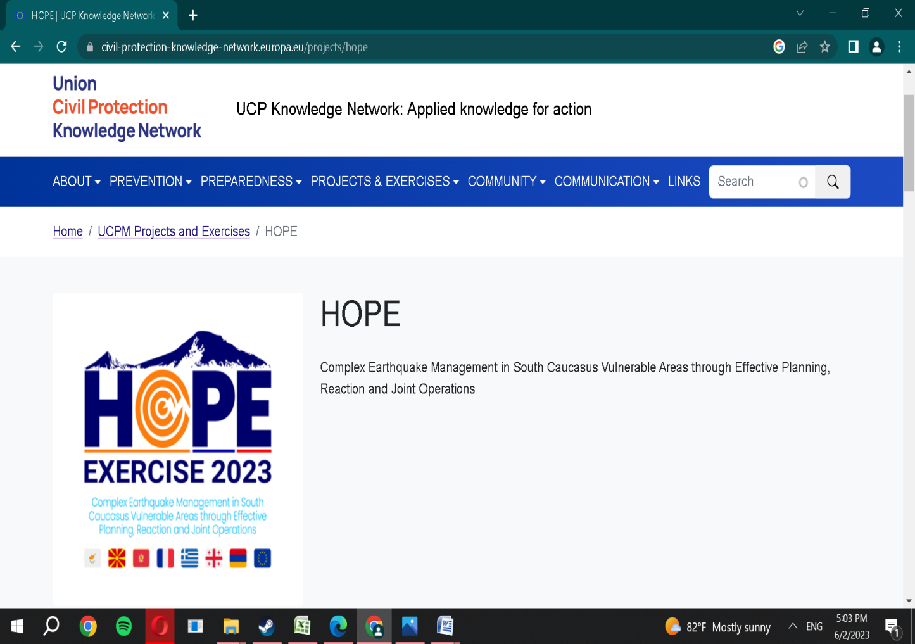

**HOPE FACEBOOK PROFILE AND QR CODE**

**[](https://www.facebook.com/people/HOPE-FSX-Project/100088600230831/)** 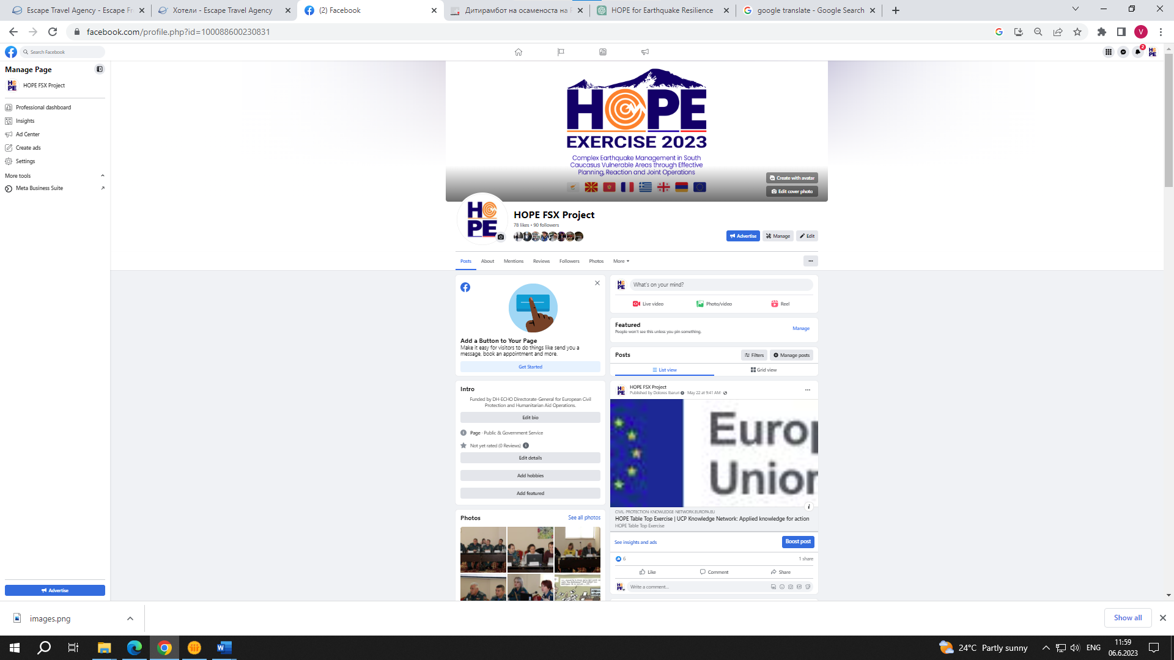

**HOPE VISUAL IDENTITY**

The visual identity of the HOPE project plays a crucial role in creating a consistent and recognizable brand image for all project-related materials. It includes various elements such as the project logo, PowerPoint (PPT) templates, and newsletters. These materials are designed and printed to effectively disseminate information about the project.

**Logo:** The HOPE project logo serves as the primary visual representation of the project. It should be used consistently across all project-related materials, ensuring a cohesive and professional look. The logo should not be modified or distorted in any way that may compromise its integrity and legibility.

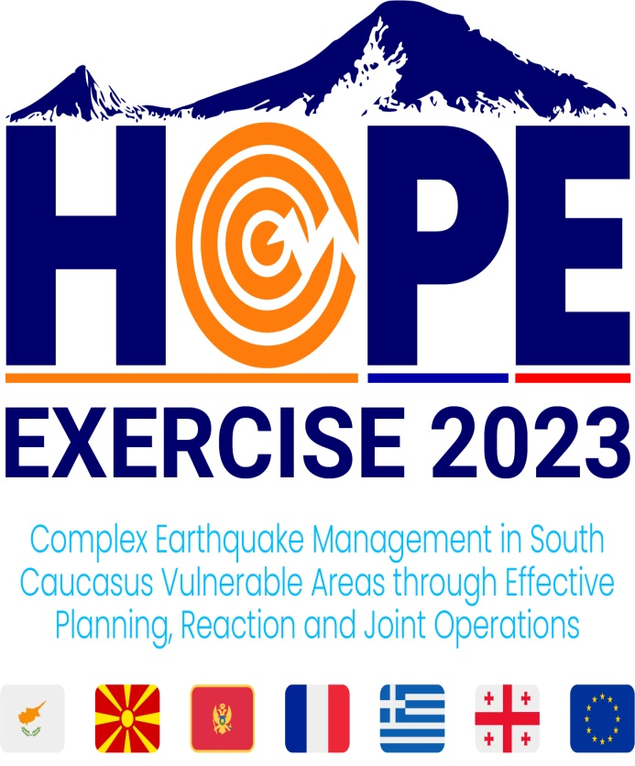

**PPTx Template**: A customized PowerPoint template has been created for the HOPE project to maintain a consistent visual identity in presentations. This template includes the project logo, appropriate color schemes, fonts, and formatting guidelines. Users are encouraged to utilize the PPT template when creating project-related presentations to maintain brand consistency.

** **

**Newsletters:** The project team has developed a newsletter template to facilitate regular communication and updates with stakeholders. The template incorporates the HOPE project logo and appropriate branding elements to ensure a cohesive visual identity. The newsletter design should be consistent throughout various editions, maintaining a professional and recognizable look.

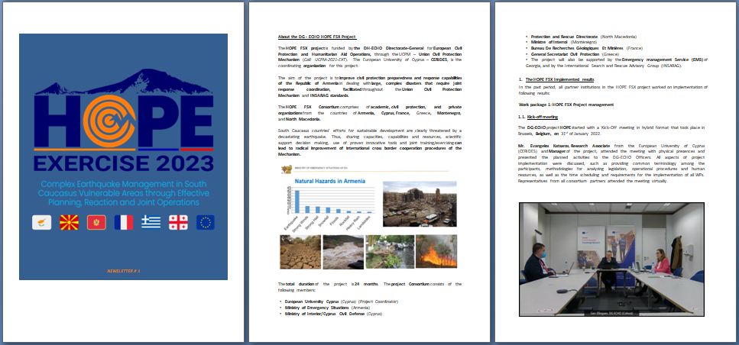

**Electronic Availability**: The templates mentioned above, including the PPT template and newsletter template, are provided in electronic format to project stakeholders. This allows for easy access and usage, ensuring consistent branding across all project-related documents and materials.

**Maintaining Consistency**: It is important to adhere to the established visual identity guidelines to maintain a cohesive and professional image for the HOPE project. All project partners and stakeholders are encouraged to use the provided templates and follow the branding guidelines to ensure consistency in the dissemination of project information.

Top of Form

**The HOPE project consortium has planned various dissemination activities and materials. Here are the key points**:

1. **Use of Dropbox platform**: The consortium will utilize the Dropbox platform to upload and share relevant information about dissemination activities. Each partner will have access to their institution's folder, where they can upload reports, materials, photos, videos, and other related information.
2. **Technical publications**: The consortium intends to prepare three technical publications on specific topics: a) Use of drones in earthquake management operations, leveraging the expertise of Unisystems and the Cyprus Civil Defence team. b) Protection of cultural heritage monuments in earthquakes, considering the significance of cultural assets in certain regions. c) Health, safety, and support for first responders, addressing an important but often overlooked aspect. The large earthquake scenario of the exercise provides an opportunity to address this issue and generate valuable publications.
3. **Proactive dissemination**: The aim of the publications and promotional materials is to make the content available to the general public and end-users, providing information on the project's background, objectives, work description, and expected results. Proactive dissemination of data and messages to identified target audiences is crucial.
4. **Press releases**: At a minimum, a press release will be issued at the start and conclusion of the project to communicate project updates and outcomes.
5. **Media coverage**: Project dissemination should occur through the media services of the project partners' institutions. National and local television coverage of project events is also desired. Identifying relevant media outlets and keeping them informed about project milestones and outcomes should be done at the beginning of the project.

These measures demonstrate the consortium's commitment to disseminating information about the HOPE project to various stakeholders, the general public, and the media

**DELIVERABLES/TYPE/LB/DISSEMINATION LEVEL OF RESULTS**

|  |  |  |  |  |
| --- | --- | --- | --- | --- |
| **Deliverable 1.1 Description** | **WP / Lead Beneficiary** | **Type** | **Dissemination level** | **Due date (month)** |
| Project Management Structures, in report and flowchart in English Language | WP 1/ EUC | Document, report | Public | 2 |
| **Deliverable 1.2 Description** | **WP / Lead Beneficiary** | **Type** | **Dissemination level** | **Due date (month)** |
| Project Meetings and Minute/Agenda, minutes, photos, presentations, material, for all project events | WP 1/ EUC | Document, report | Public | 24 |
| **Deliverable 1.3 Description** | **WP / Lead Beneficiary** | **Type** | **Dissemination level** | **Due date (month)** |
| Project report/Mid-term Progress Report | WP 1/ EUC | Document, report | Public | 12 |
| **Deliverable 1.4 Description** | **WP / Lead Beneficiary** | **Type** | **Dissemination level** | **Due date (month)** |
| Project Risk management Periodic Report/At frequent intervals to secure smooth implementation of project HOPE and anticipate for implementation difficulties | WP 1/ EUC | Document, report | Public | 24 |
| **Deliverable 2.1 Description** | **WP / Lead Beneficiary** | **Type** | **Dissemination level** | **Due date (month)** |
| Kick Off minutes and Study Visit Report, minutes, presentations, list of participants, photos and Study Visit Report | WP2/MES | Document, report/ | Public | 2 |
| **Deliverable 2.2 Description** | **WP / Lead Beneficiary** | **Type** | **Dissemination level** | **Due date (month)** |
| 1st Planning Conference Minutes, presentation’ list of participants, photos, and Draft Exercise Manual | WP2/MES | Document, report/ | Public | 5 |
| **Deliverable 2.3 Description** | **WP / Lead Beneficiary** | **Type** | **Dissemination level** | **Due date (month)** |
| 2nd Planning Conference Minutes, Minutes, presentation’ list of participants, photos and Draft Exercise Manual – version 2 | WP2/MES | Document, report/ | Public | 9 |
| **Deliverable 2.4 Description** | **WP / Lead Beneficiary** | **Type** | **Dissemination level** | **Due date (month)** |
| 3rd Planning Conference Minutes, presentation’ list of participants, photos, and Final Exercise Manual | WP2/MES | Document, report/ | Public | 13 |
| **Deliverable 3.1 Description** | **WP / Lead Beneficiary** | **Type** | **Dissemination level** | **Due date (month)** |
| Table Top Exercise and Report, Full reporting (including videos etc.) of the Implementation of Table Top Exercise, in English | WP3/MES | Other | Public | 17 |
| **Deliverable 3.2 Description** | **WP / Lead Beneficiary** | **Type** | **Dissemination level** | **Due date (month)** |
| Command Post Exercise and Report, full reporting (including videos etc.) of the Implementation of Command Post Exercise, in English language | WP3/MES | Other | Public | 22 |
| **Deliverable 3.3**  **Description** | **WP / Lead Beneficiary** | **Type** | **Dissemination level** | **Due date (month)** |
| Full Scale Exercise and Report, Full reporting (including videos etc.) of the Implementation of Full-Scale Exercise, in English language | WP3/MES | Other | Public | 22 |
| **Deliverable 4.1**  **Description** | **WP / Lead Beneficiary** | **Type** | **Dissemination level** | **Due date (month)** |
| Presentations, templates, etc. with HOPE and EU logo, in English Language | WP4/DPZ | Other | Public | 2 |
| **Deliverable 4.2**  **Description** | **WP / Lead Beneficiary** | **Type** | **Dissemination level** | **Due date (month)** |
| Layman’s report in paper and digital format in English language | WP4/EUC | Document, report | Public | 24 |
| **Deliverable 4.3**  **Description** | **WP / Lead Beneficiary** | **Type** | **Dissemination level** | **Due date (month)** |
| Website and Social Media HOPE account | WP4/DPZ | DEC —Websites, patent filings, videos, etc | Public | 3 |
| **Deliverable 4.4**  **Description** | **WP / Lead Beneficiary** | **Type** | **Dissemination level** | **Due date (month)** |
| Three technical publications/analyzing topics addressed by HOPE project | WP4/EUC | Other | Public | 24 |
| **Deliverable 4.5**  **Description** | **WP / Lead Beneficiary** | **Type** | **Dissemination level** | **Due date (month)** |
| Media works and events, with reports, presentations’ list, media coverage etc. | WP4/MES | Other | Public | 24 |
| **Deliverable 4.6**  **Description** | **WP / Lead Beneficiary** | **Type** | **Dissemination level** | **Due date (month)** |
| Brochures, leaflets, flyers, banners, newsletters and other publication | WP4/DPZ | Other | Public | 24 |
| **Deliverable 4.7**  **Description** | **WP / Lead Beneficiary** | **Type** | **Dissemination level** | **Due date (month)** |
| Exercise training and raising awareness video | WP4/MES | DEC —Web sites, patent filings, videos, et | Public | 24 |
| **Deliverable 4.8**  **Description** | **WP / Lead Beneficiary** | **Type** | **Dissemination level** | **Due date (month)** |
| Participatory GIS platform with full record of activities | WP4/EUC | Other | Public | 12 |
| **Deliverable 5.1**  **Description** | **WP / Lead Beneficiary** | **Type** | **Dissemination level** | **Due date (month)** |
| Exercise Evaluation Plan in English Language | WP5/EUC | Other | Public | 16 |
| **Deliverable 5.2**  **Description** | **WP / Lead Beneficiary** | **Type** | **Dissemination level** | **Due date (month)** |
| Evaluators Training Meeting Package in English Language | WP5/EUC | Other | Public | 17 |
| **Deliverable 5.3**  **Description** | **WP / Lead Beneficiary** | **Type** | **Dissemination level** | **Due date (month)** |
| Hot wash Session Agenda and Minutes in English Language | WP5/EUC | R — Document, report | Public | 22 |
| **Deliverable 5.4**  **Description** | **WP / Lead Beneficiary** | **Type** | **Dissemination level** | **Due date (month)** |
| Exercise Evaluation Report in English language | WP5/EUC | R — Document, report | Public | 23 |
| **Deliverable 6.1**  **Description** | **WP / Lead Beneficiary** | **Type** | **Dissemination level** | **Due date (month)** |
| Way Forward Meeting/Full report of the Way Forward meeting. In English language | WP6/MES | R — Document, report | Public | 23 |
| **Deliverable 6.2**  **Description** | **WP / Lead Beneficiary** | **Type** | **Dissemination level** | **Due date (month)** |
| Way Ahead Action Plan/ The Action plans for Way ahead will be very detailed with specific steps and obligations, time frame and engaged entities, In English language | WP6/EUC | Other | Public | 23 |
| **Deliverable 7.1**  **Description** | **WP / Lead Beneficiary** | **Type** | **Dissemination level** | **Due date (month)** |
| 1st Training Event/Organized in Yerevan during the 2nd Planning Conference time period on mainstreaming the Results of DG ECHO and International Exercises projects | WP7/MES | R — Document, report | Public | 9 |
| **Deliverable 7.2**  **Description** | **WP / Lead Beneficiary** | **Type** | **Dissemination level** | **Due date (month)** |
| 2nd Training Event/Organized in Yerevan during the Table Top Exercise time period on Health, Safety and After Disaster Support / Care of 1st Responders | WP7/MES | R — Document, report | Public | 17 |
| **Deliverable 7.3**  **Description** | **WP / Lead Beneficiary** | **Type** | **Dissemination level** | **Due date (month)** |
| 3rd Training Event/Co organized in Tbilisi (Georgia) with Emergency management Service (EMS) on Cross Border Cooperation | WP7/MES | R — Document, report | Public | 18 |
| **Deliverable 7.4**  **Description** | **WP / Lead Beneficiary** | **Type** | **Dissemination level** | **Due date (month)** |
| 4th Training Event/Co-organized in Tbilisi (Georgia) with Emergency management Service (EMS) on Disasters Emergency Logistics and Regional Approach to Host Nation Support | WP7/MES | R — Document, report | Public | 21 |

**News and documents template for HOPE project:**

This template should be used by all project partners for publishing news and final deliverables.

|  |  |
| --- | --- |
| **Partner institution** |  |
| **News/ Event/Deliverable Title** |  |
| **News text/ short description of deliverable (text for web site)** | |
|  | |
| **Attachments (if any)** | |
| **Agenda of event** | **Title of document (PDF)** |
| **Attendance sheet** | **Title of document (PDF)** |
| **Minutes of meeting** | **Title of document (PDF)** |
| **Presentations** | **List of presentations with Titles (PDF)** |
| **Photos for gallery** | **(ZIP, JPG)** |

It is important to send news and relevant documents for every project-related activity to ensure effective dissemination. By sharing news and documents about these activities, we keep stakeholders, partners, and the public informed about the progress, outcomes, and impact of the project. It helps to raise awareness, promote collaboration, and ensure transparency in the project implementation.

**The key messages to be disseminated through the HOPE project are:**

1. **Enhancing earthquake management**: The HOPE project aims to improve earthquake management in vulnerable areas through effective planning, reaction, and joint operations.
2. **Cooperation and collaboration**: The project promotes cooperation and collaboration among participating countries, organizations, and stakeholders to strengthen disaster response capabilities.
3. **Knowledge sharing and capacity building:** HOPE facilitates the sharing of knowledge, best practices, and innovative approaches in earthquake management to enhance the capacity of response teams and relevant authorities.
4. **Protection of cultural heritage**: The project highlights the importance of protecting cultural heritage monuments during earthquakes, recognizing their economic, cultural, and historical significance.
5. **Health, safety, and support for first responders**: HOPE focuses on the well-being and safety of first responders, emphasizing the need for proper training, equipment, and support systems.
6. **European Civil Protection Mechanism**: The project showcases the effectiveness and benefits of the European Civil Protection Mechanism in coordinating international assistance during emergencies.
7. **Public awareness and engagement**: HOPE aims to raise public awareness about earthquake risks and preparedness, encouraging individuals and communities to take proactive measures for their safety.
8. **Policy influence**: The project seeks to influence policy development and decision-making processes at national and regional levels, advocating for improved earthquake management strategies.

**Key conclusions of the dissemination and visibility of the HOPE project:**

1. **Dissemination Plan**: The project has developed a detailed dissemination plan that outlines strategies, activities, and a timeline for disseminating project outcomes. This plan should be regularly reviewed and updated to ensure maximum visibility and impact.
2. **Targeted Communication Channels**: The project utilizes various communication channels, including social networks, the UCPM Knowledge network, media campaigns, and lifelong learning programs, to reach the project's target audience effectively. These channels ensure that relevant stakeholders are informed about project activities, achievements, and opportunities for engagement.
3. **Project Visibility and Image**: Effective visibility and communication positively impact the project's image and perception by promoters and the public. A strong and positive image of the project and the EU allows for sharing results and lessons learned at the highest level, contributing to the overall impact and sustainability of the project.
4. **Stakeholder Engagement**: The project actively engages with relevant stakeholders, including scientific, engineering, economic, and governmental sectors, to enhance the potential and visibility of its results. Stakeholder workshops, consultation sessions, and participation in external events provide opportunities for knowledge-sharing, collaboration, and establishing connections.
5. **Long-term Dissemination**: The dissemination and visibility efforts extend beyond the project's duration to ensure sustained impact and recognition. Project outcomes, including reports, deliverables, procedures, lifelong learning materials, and good practices, will be made visible and publicized on various platforms, ensuring accessibility beyond project completion.
6. **Monitoring and Evaluation**: Monitoring and evaluating the effectiveness of the dissemination activities are crucial. Tracking website analytics, social media engagement, media coverage, and conducting surveys or interviews with the target audience allow for assessing the project's visibility, impact, and knowledge uptake.
7. **Consistent Visual Identity**: A strong visual identity, represented by the project logo, PowerPoint templates, and newsletters, ensures consistency and recognition across all project-related materials. Adhering to the established visual identity guidelines contributes to a cohesive and professional image for the project.