Risk Communication Tool 5: Countering Mis-, Dis-, and Mal-information
Mis-, dis-, and mal-information (MDM) can undermine preparedness and emergency response efforts by creating confusion, eroding trust in public authorities, and reducing public willingness to follow risk reduction and safety recommendations. During emergencies, MDM may spread quickly both online and offline across digital and traditional media. Civil Protection authorities and other Disaster Risk Management actors need to monitor the information environment, communicate proactively, shape public understanding, and work with trusted partners to promote accurate, evidence-based information.
- Understanding MDM
While MDM differ in terms of intent, all three have the potential to shape public behaviour (e.g. reduce compliance with instructions from authorities) and undermine both preparedness and response activities. Though understanding the difference between the three can help authorities assess information risks, in practice, response decisions should be guided primarily by the potential harm and reach of the information.
Type | Definition | Example
Misinformation | Information that is false, but not created with the intention of causing harm. | A person shares a parody news article through social media, believing it to be true, with no intent to cause harm.
Disinformation | Information that is false and deliberately created to harm a person, social group, organisation or country. | A malicious actor manipulates statistics regarding a sensitive topic, as part of an effort to obtain wide-spread support of specific political views.
Malinformation | Information that is based on reality, used to inflict harm on a person, organisation or country. | A malicious actor publishes leaked, genuine internal documents and the personal details of an emergency official, stripped of context, to damage trust in the response and incite harassment.
Source (definitions): Council of Europe, Information Disorder: Toward an Interdisciplinary Framework for Research and Policy Making (Wardle & Derakhshan, 2017).
- Building resilience before MDM spreads
Preventing and mitigating the impacts of MDM starts long before it appears. A few key actions to reduce the risk, identify emerging concerns , and respond in a timely and proportionate manner include:
- Work with the media: Long-term partnerships with journalists and media outlets can help increase the consistency and accuracy of messages during a crisis. These relationships are best established before crises occur and can support the rapid dissemination of accurate information, help address information gaps, and strengthen public trust during emergencies. For further information, you can refer to Tool 3 (Working with the media and other partners).
- Leverage civil society expertise and networks: Fact-checking organisations, volunteer networks, and other trusted civil society organisations (CSOs) can help identify emerging rumours, reach groups at risk, promote media literacy, and amplify accurate information. Establishing partnerships before crises occur can strengthen resilience to MDM and support a whole-of-society approach to preparedness.
- Promote media and information literacy: Helping people understand how information is created, shared, and manipulated can strengthen resilience to MDM. Public awareness initiatives and educational activities can help citizens critically assess information, identify unreliable sources, and make informed decisions before and during emergencies.
- Inoculate against MDM: Interventions (e.g. short games, videos or messages) that expose people to weakened examples of common manipulation techniques (e.g. emotionally manipulative language, false dichotomies, impersonation of official sources) improve people's ability to recognise manipulative content. Such interventions should be repeated periodically.
- Establish and sustain trusted communication channels: People are more likely to rely on and share information from their preferred communication channels. Maintaining reliable channels across different categories (broadcast, digital, direct, or print) before emergencies occur helps establish trusted sources of information that can be activated during crises. For further information, you can refer to Tool 2 (Choosing communication channels).
- Communicate early and acknowledge uncertainty: Silence from authorities can create spaces that are quickly filled by unverified information. Share accurate information as early as possible to build credibility and prevent information gaps. Be clear about what is known, what remains uncertain, and what is being done to find out more. Transparency about uncertainty and timely corrections can help maintain public trust.
- Identify communication vulnerabilities: Authorities should assess where misunderstandings or misleading narratives are most likely to emerge due to specific vulnerabilities (e.g. politically sensitive or highly emotional topics). Understanding these vulnerabilities enables organisations to anticipate risks and prepare communication responses in advance.
- Prepare communication protocols and resources: Developing communication protocols, key messages, and coordination mechanisms before an emergency can support rapid and consistent responses when an emergency arrives or when misleading information emerges. Roles and responsibilities for communication, monitoring, escalation, and approval processes should be clearly defined beforehand.
- Monitor the information environment: Regular monitoring of traditional and digital media can help identify emerging narratives, information gaps, rumours, and misleading claims before they become widespread. Monitoring should focus not only on individual pieces of content but also on broader narratives, public concerns, and changing information needs. Monitoring should also cover encrypted messaging apps where rumours often circulate, and pay particular attention to unanswered public questions (i.e. the 'information voids' that MDM tends to fill first).
Case example | Key takeaways
Virtual Operations Support Teams (VOST)  Portugal | - Volunteer networks can help identify MDM before they become widespread, support the dissemination of verified information and help reinforce official messages across communities and social media.  - Partnerships established before emergencies occur are more effective during periods of heightened information uncertainty.
Who Influences Your Attitude? Denmark | - Raising awareness of manipulation techniques can strengthen resilience before misinformation spreads.  - Public awareness campaigns can reduce vulnerability to future misinformation and support societal preparedness.
Matilda.es WhatsApp Chatbot  Spain | - Providing simple verification tools through widely used platforms can help citizens quickly check suspicious content and reduce the spread of MDM.  - Directing users to verified information and fact-checked content can strengthen trust in reliable sources during emergencies.
- Taking action against MDM
  - Assessing if and how to respond
Not all instances of MDM require a public response. Before taking action, authorities should assess the potential impact of the MDM on preparedness, public trust, and emergency response efforts, as well as its level of visibility and reach. Responses should be proportionate to the risk and should be designed to reduce harm while avoiding the amplification of false or misleading narratives. Concrete criteria (e.g. the speed of spread, movement across platforms or communities, pick-up by influential accounts or mainstream media, and potential to change protective behaviours), can help define when a public response becomes necessary.
  - Choosing an appropriate response
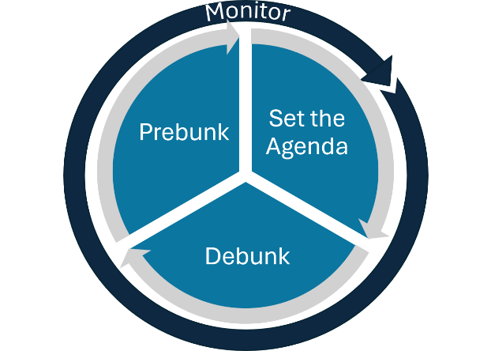
Ongoing monitoring of the information environment should inform the choice of response. Depending on the nature, reach, and potential impact of MDM, authorities may decide to prebunk, set the agenda, or debunk misleading information.
Prebunking aims to build resilience and build media literacy before MDM takes hold by proactively addressing misconceptions, explaining manipulation techniques, and providing accurate information early. It should prioritise targeting manipulation techniques behind MDM, as technique-based inoculation generalises across topics and claims. Prebunking messages should be repeated and refreshed, as effects decay over time.
Agenda-setting involves providing timely, accurate, and transparent information on emerging issues before false narratives become established.
Debunking involves directly correcting MDM information. Evidence-based debunks lead with the accurate information, warn before briefly mentioning the false claim (stated once only), explain why it is false or which manipulation technique it uses, and close by repeating the accurate information. Debunking is most effective it comes from messengers the audience trusts, is paired with clear guidance on what people should do, and is repeated across channels: .
More information | - European Commission: Countering information manipulation  - European Commission: 6 tips to spot and stop information manipulation  - Council of Europe: Information Disorder - Freedom of Expression  - Lewandowsky, Cook, Ecker et al.: The Debunking Handbook 2020  - WHO: Infodemic management resources

TOP TIPS
- Trust: Build trust and communication networks between citizens, authorities, and other relevant stakeholders, before a crisis occurs.
- Be first, be honest: Communicate early, express empathy, and openly acknowledge uncertainty - silence leaves information voids that MDM fills.
- Listen: Monitor relevant channels regularly and flag emerging concerns and information gaps early.
- Prepare: Agree (and test) roles, responsibilities and communication procedures in advance.
- Partner: Build a network of trusted media and CSOs contacts you can activate when needed.
- Respond proportionately: Before responding, assess whether the issue requires action and choose the least amplifying and most effective intervention.
- Learn and adapt: Review your communication after any major intervention and continuously evaluate and adjust your approach accordingly.

